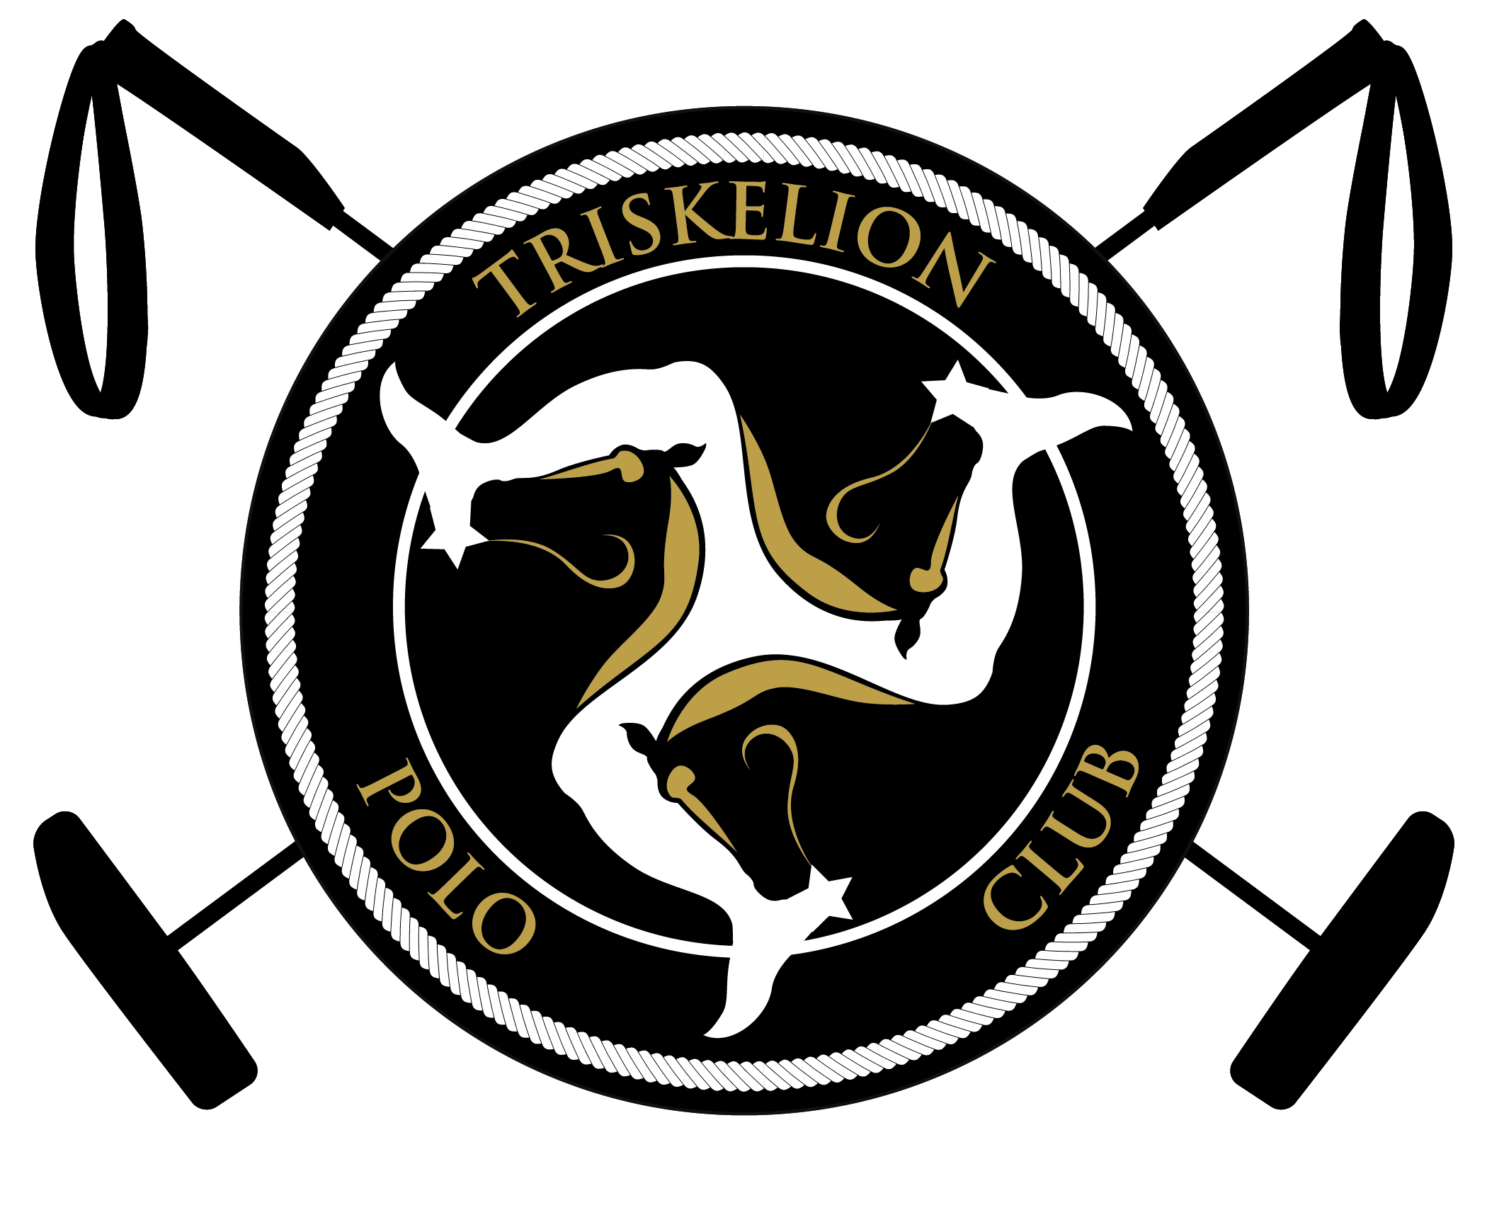
Triskelion Polo Club
Summer 2020 Membership form
Title (Mr., Mrs, Etc.):………………………………………………………….
Name:………………………………………………………………………….
Date of Birth (DD/MM/YYYY:…………………………………………………
Email Address:…………………………………………………………………...
HPA Handicap:………………………………………………………………….
Other Handicaps:………………………………………………………………
Umpire Grade:…………………………………………………………………..
Address:………………………………………………………………………………………………………………………………………….
Triskelion Membership: Full £750 Student £500* Family Membership Discount of 10% **
*Only available to those aged 18 or under on January 1st 2019 or in full time education
**Only available if a relative or spouse from your household holds a Family Triskelion Polo Club Membership
If this membership form is presented to the polo manager after April 12th 2020 you will be eligible for a £50 late fee on all memberships
Membership Agreement
As a member I agree to the following:
I agree that when participating in a polo related activity:
- I will not ride any horse harshly or in a way that would bring the sport of polo into disrepute.
- I will not use tack that is dangerous, ill-fitting or overly harsh in a way that would bring the sport of polo into disrepute. This will be defined at the discretion of the Polo Manager, the General Manager or the Welfare Officer.
- If a complaint is made, I will submit to a welfare panel and assist in their investigation with honesty and to the best of my abilities. If required I will submit to an investigation by the HPA Welfare Stewards, should it be referred by the Triskelion Polo Club Welfare Panel. I will accept the findings of either panel and any punishments they deem appropriate.
- If a horse I am riding begins to show vice (eg. kicking, becoming uncontrollable) and I am not taking steps to improve the situation in the opinion of the umpire or polo manager then my horse may receive a ban until behavioural changes have been made.
- I will not behave in a way that will bring the sport of polo into disrepute. I understand that violence and rude behaviour will not be tolerated under any circumstances. I will, if asked, submit myself to a Triskelion Polo Club disciplinary panel or an HPA disciplinary panel and accept any punishments that are deemed appropriate.
Triskelion Polo Club has moved to new facilities for the 2019 season and I understand the risks which may include, but are not limited to, ground subsidence, animal holes and burrows, low branches, machinery and incomplete infrastructure such ponylines or fencing. I will abide by the instruction of any Triskelion Polo Club agent, employee or any other representative with regard to the conducting of polo activities and specifically the area in which I will conduct them. If I notice a hazard I will bring it to the attention of the General Manager and stay clear of the hazard(s).
I agree that I must give 48 hours notice for the cancelation of a lesson or chukkas. Should I cancel within 48 hours of the activity and I am unable to provide a substitute, I will pay the full price for another player to take my place including circumstances where I was not originally required to pay or pay a lesser rate.
I agree that once I have made an entry into a tournament or match, I am committed to play from that point on. If I am unable to play having already committed to the match or tournament I will pay the costs in full to all parties for a substitute to take my place.
I enter the premises understanding the risks and dangers of taking part in all polo activities and that participation in the sport is voluntary and at my own risk. I assume sole responsibility for any injury, death or property damage that I may suffer as a result of my participation in polo or my presence on the premises.
I agree to indemnify and hold harmless the HPA, host club, all other members, entrants, spectators or attendees and any other sponsor, charity or other beneficiary which may benefit from an event, and all directors, governors, officers, trustees, agents, employees, or servants of any of the above named entities (collectively the “Indemnified Parties”), from any claim, for any personal injury or property damage sustained by any person or entity, including, without limitation, all third parties, all other members, entrants and any person performing services for any of the Indemnified Parties, caused in any club or HPA or Triskelion Polo Club sanctioned activity, tournament or ground by myself, my agents, employees and/or their mounts.
I am responsible for any injury or damage caused by myself, my agents, employees and/or their mounts, and to bear the costs of any legal proceedings which I might initiate.
Print Name:…………………........................................ Signed:…………………………………………………………..
If under 18:
Parent/Guardian:………………………………………. Signed:……………………………………………………………
Date:……/………/………

